Grey County Logo Public Notice

May 12, 2016

# 2016 Summer Road Construction

Over the next few months, Grey County will be completing seasonal road work across the region. For a full construction map, please visit [www.grey.ca/roads](http://www.grey.ca/roads) and select the interactive map.

## Upcoming Road Closures

Some construction projects require the temporary closure of a road. These projects are listed below. All dates are best estimates and are subject to minor changes.

### Grey Road 170 – Road Construction and Bridge Replacement

Grey Road 170 will be closed for bridge replacement from July 15, 2016 to September 2, 2016. The bridge is located approximately northeast of Shallow Lake.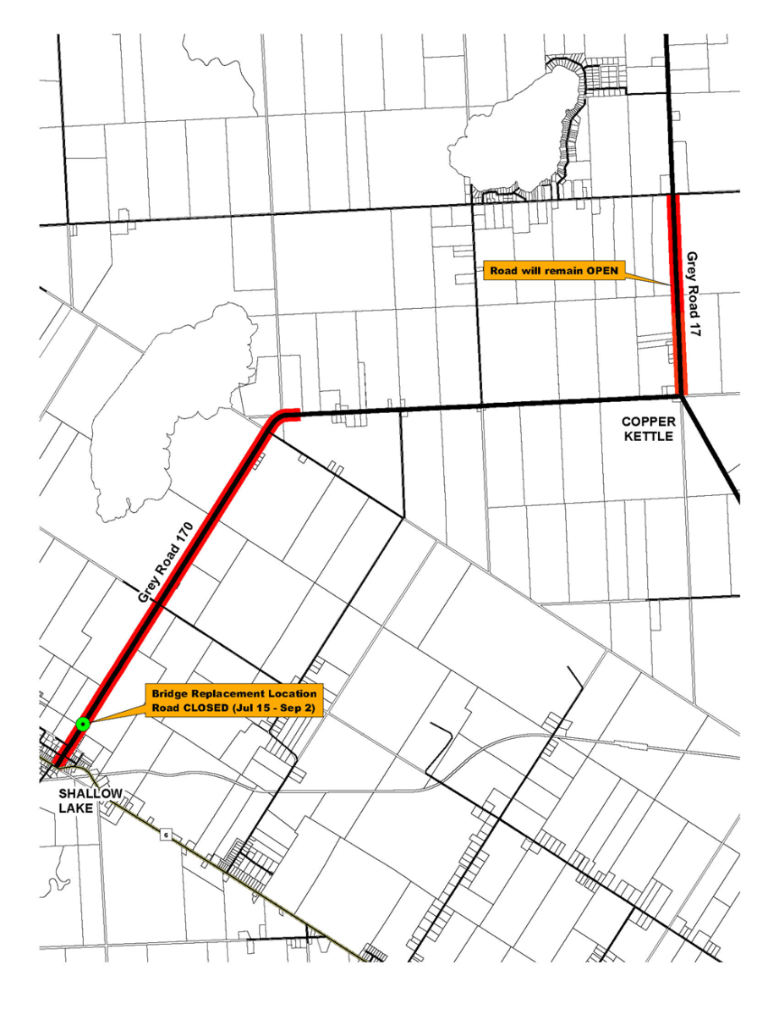

### Grey Road 31 – Bridge Maintenance

Grey Road 31 will be closed for bridge maintenance from May 16, 2016 to June 3, 2016. The road will be closed between Grey Road 2 and Grey Highlands Road 55 with a detour one concession south. Follow signs D-1 from the west and D-2 from the east.

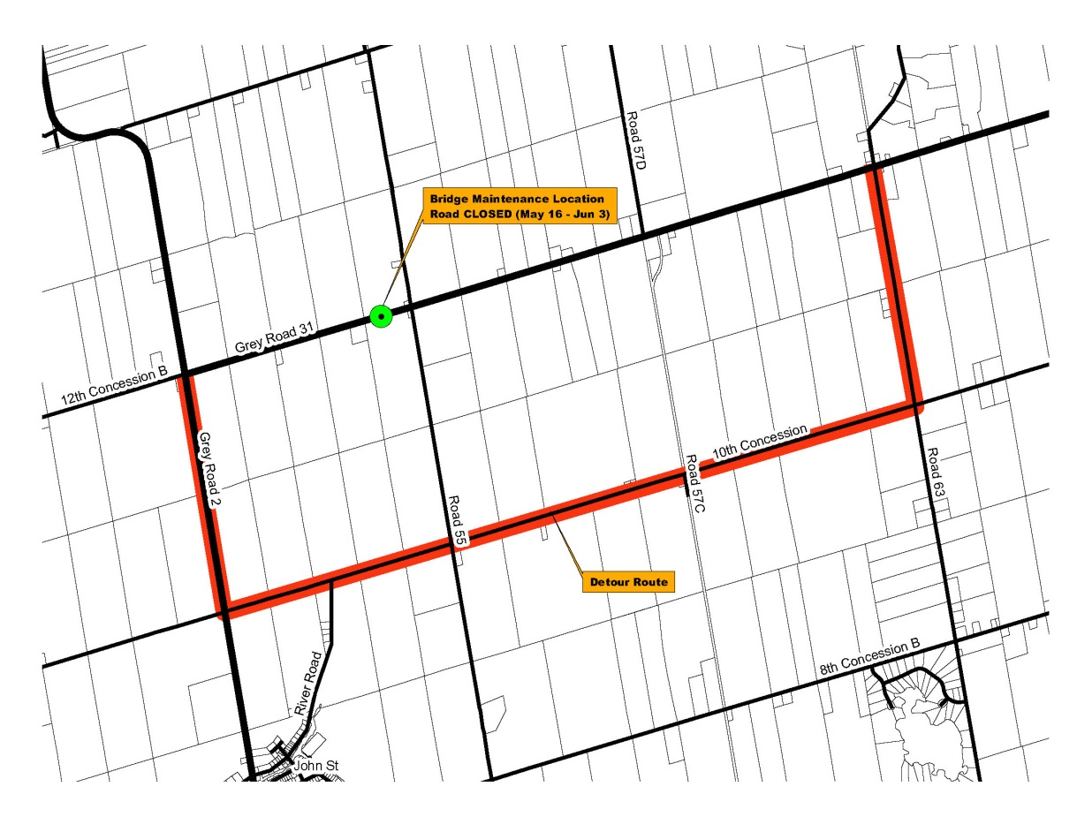

### Grey Road 40 – Road Construction

Grey Road 40 will be under construction from May 16, 2016 to June 10, 2016. Construction will take place between the Grey-Bruce Line and Grey Road 3. Alternating lane closures are expected throughout the project.

### City of Owen Sound Construction - Eddie Sargent Parkway

Construction began on the Eddie Sargent Parkway on May 2, 2016 resulting in lane reductions for two weeks with land restrictions to follow.

### Ministry of Transportation Construction – Alvanley Roundabout

The MTO is constructing a roundabout at the intersection of Highway 21 and the Grey-Bruce Line later this year. The project will result in road closures and detours. More information will be shared later in the year as details are known.

For more information, email [roads@grey.ca](mailto:roads@grey.ca) or call 1-800-567-4739.